SCH4U - Acid-Base Review

- What defines a chemical as an Arrhenius acid? Base?

Acid- dissociates in water to produce H⁺
Base- dissociates in water to produce OH⁻

- What defines a chemical as a Bronsted-Lowry acid? Base?

Bronsted-Lowry Acid- donates a proton
Bronsted-Lowry Base- accepts a proton

- Name 2 everyday acids and 2 everyday bases.

Answers will vary, some examples:
Vinegar, Lemon juice
Baking soda, Tums

- What defines a chemical as a strong acid? Base?
Strong acids and strong bases completely dissociate in water

- What defines a chemical as a weak acid? Base?
Weak acids and weak bases partially dissociate in water.

- List 3 strong acids.
Answers will vary examples: HCl, HNO₃, H₂SO₄, H₃PO₄

- Give an example of a weak acid.
Answers will vary. CH₃COOH

- List 3 strong bases.
Answers will vary. NaOH, KOH, Ca(OH)₂, Mg(OH)₂, LiOH

- Give an example of a weak base.

Example: NH₃

- What is the formula to determine the pH of a solution?
pH= -log[H₃O⁺] or pH= -log[H⁺]

- What is the formula to determine the pOH of a solution?

pOH= -log[OH⁻]

- What is the pH of a solution of HCl with a concentration of 0.1M?

pH=1

- What is the pOH of a solution of H₂SO₄²⁻ if its concentration is 0.05M?

0.05M x 2= 1M [H⁺]
pH= -log[1M]
pH=1

pOH= 14-pH
pOH=13

- What type of reaction is the following: HCl + NaOH NaCl + H2O?

Neutralization reaction

- What is an acid-base indicator?

-a substance that changes colour when exposed to acidic and basic solutions
-most are weak monoprotic acids
-the undissociated weak acid of the indicator is 1 colour, and its conjugate base is a different colour

- What is the concentration of [H+] and [OH-] ions at the equivalence point shown below?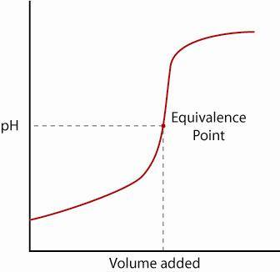

pH=7

[H⁺]= 10⁻⁷
[OH⁻] = 10⁻⁷

- What is the pOH of a solution if the [H+] is 0.2M?

pH = -log(0.2)
pH = 0.7
pOH=14-pH
pOH= 14 - 0.7
pOH= 13.3

- Identify the acid, base, conjugate acid & conjugate base for the following equilibrium:

HS⁻(aq) + H₂O(l) ↔ H₂S(aq) + OH⁻ (aq)

HS- = Acid
H₂O = Base
H₂S= conjugate acid
OH⁻= conjugate base
- What is the [OH-] in a solution with a pH=9?

[OH⁻]= 10⁻⁵M

